Handprint and Footprint Reindeer
These hand and footprint reindeers make lovely mementos.
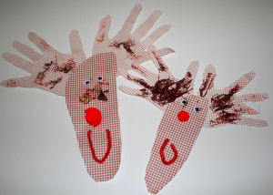
You will need:
Brown paper or card
Red pompoms for nose (or use felt or card)
Red pipe cleaners for mouth (or use red crayon or pen)
Glue and glitter
Googly eyes

Instructions:
Carefully draw around one of your child's feet onto the back of your card. Cut out.
Now draw around both of your child's hands, with fingers spread out. Cut out.
Glue the hands to the back of the widest part of the foot and decorate your reindeer.

