Christmas Collage
!
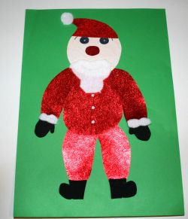
You will need:
Assortment of card, papers, craft foam, fabric, felt, stickers, glitter - get out the contents of the craft cupboard! PVA or white glue and glue stick Felt tip pens
